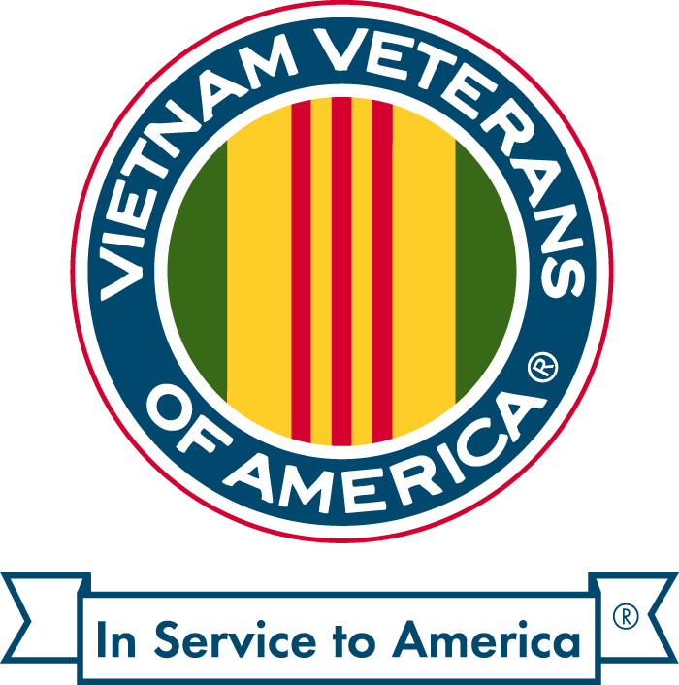
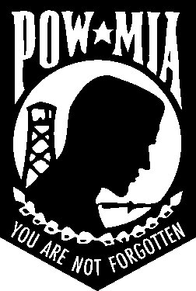
VIETNAM VETERANS OF AMERICA CHAPTER 1041 MARTIN COUNTY
PO Box 2196 Stuart, Fl 34995
vva1041@gmail.com

“All gave some, some gave all”
We Need Your Help!
Vietnam Veterans of America, Chapter 1041 is updating our Directory of Veteran Owned Businesses.
There is NO cost to you for inclusion.
These Directories are distributed at public events (fund raisers, parades, etc).
If you desire, we will add a business card ad in the Directory, for a nominal charge of $25. Please include Business card with your fee.
If you are a Veteran owned business, please complete this questionnaire and mail it to:
VVA Chapter 1041
PO Box 2196
Stuart, Fl. 34995 *** Please note the deadline for receipt is June 30, 2020

Business Name _________________________________________________________________

Business Address:
____________________________________________________________________
Type of Business:
___________________________________________________________________

Phone Number:__________________________________________________________________

Web Site: ___________________________________________________________________

Owner’s Name: ___________________________________________________________________

Branch of Service: _____________________________________________________________________

Years Served: ___________________.

E-mail for Customer Inquiries: ___________________________________________________

Thank you for your participation.

